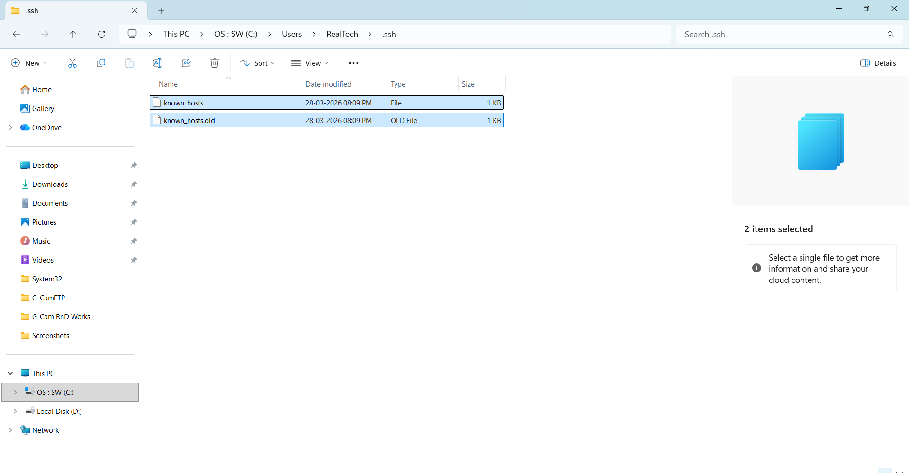
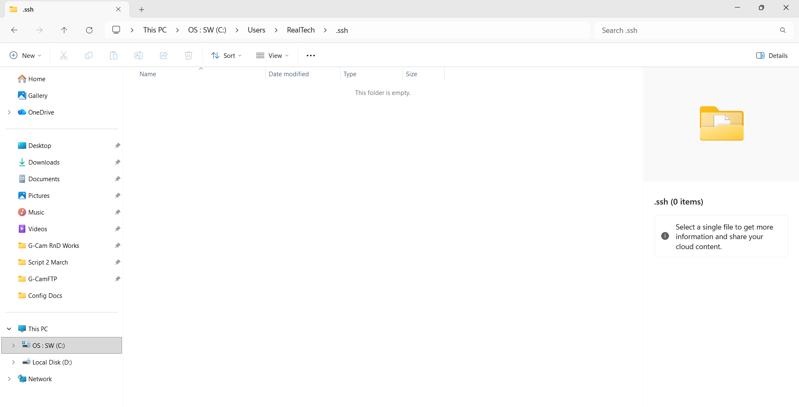
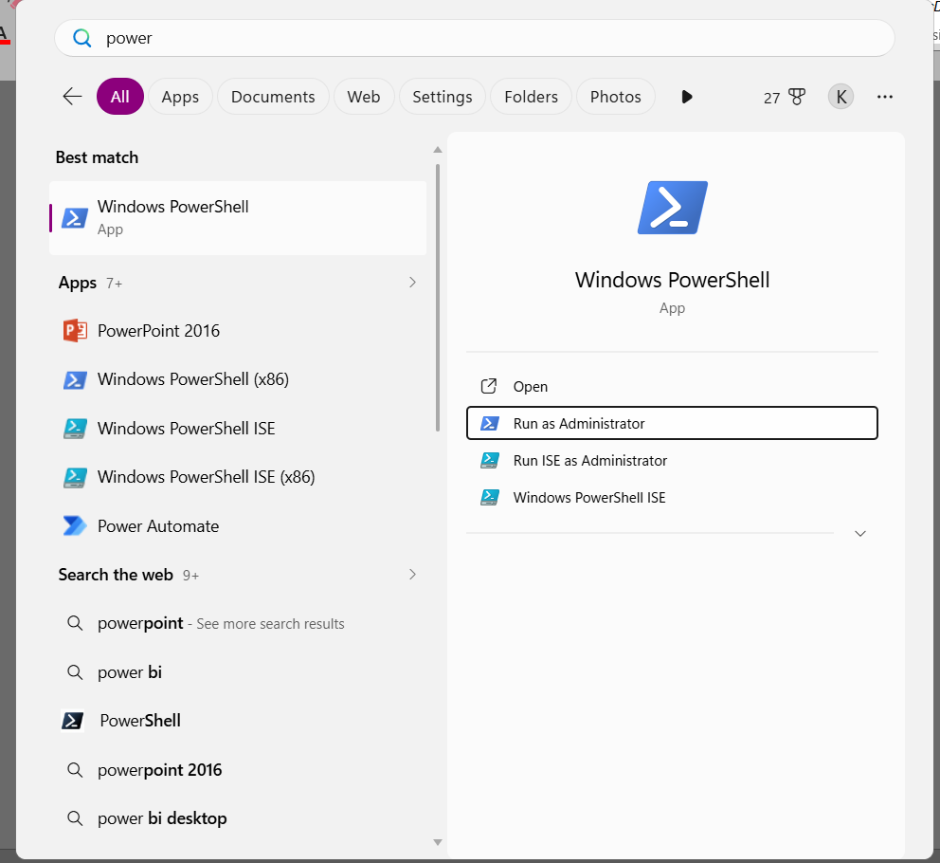
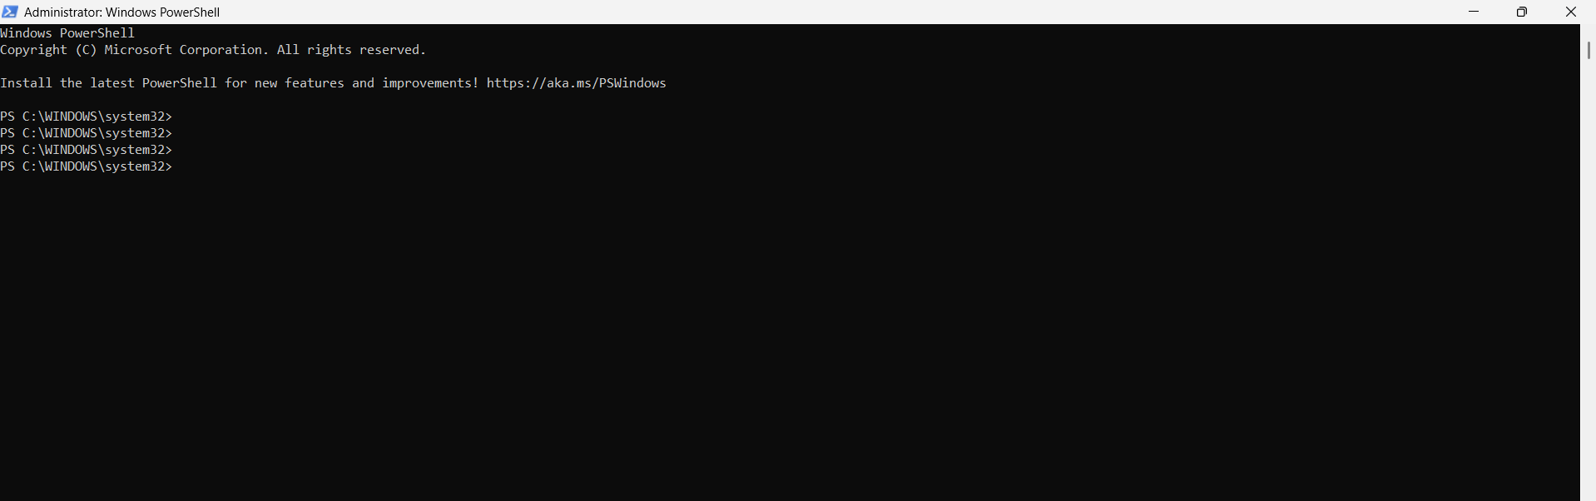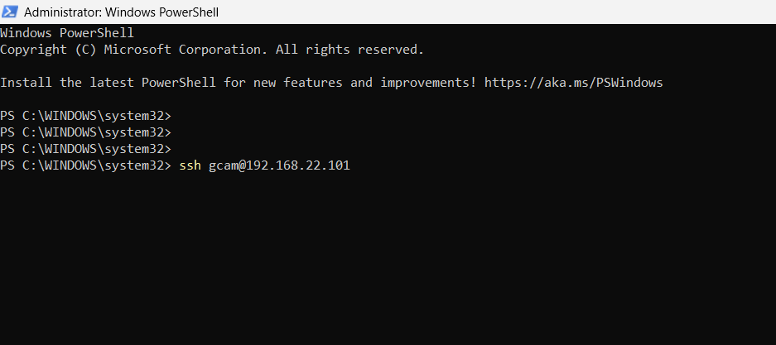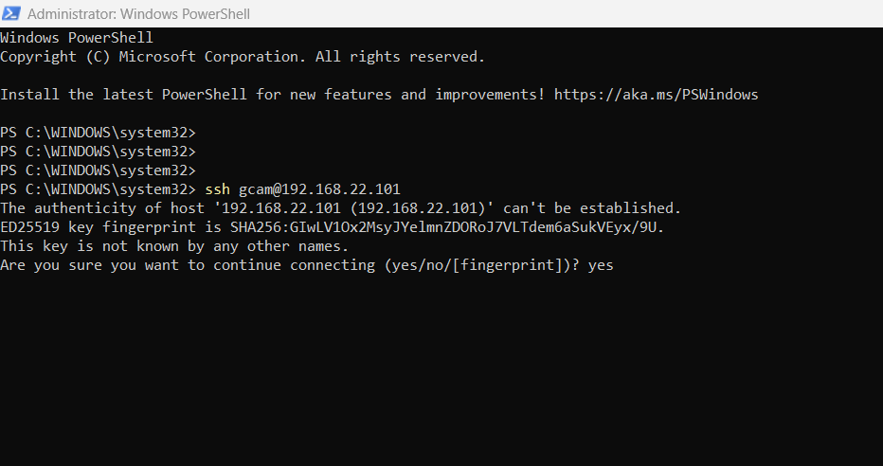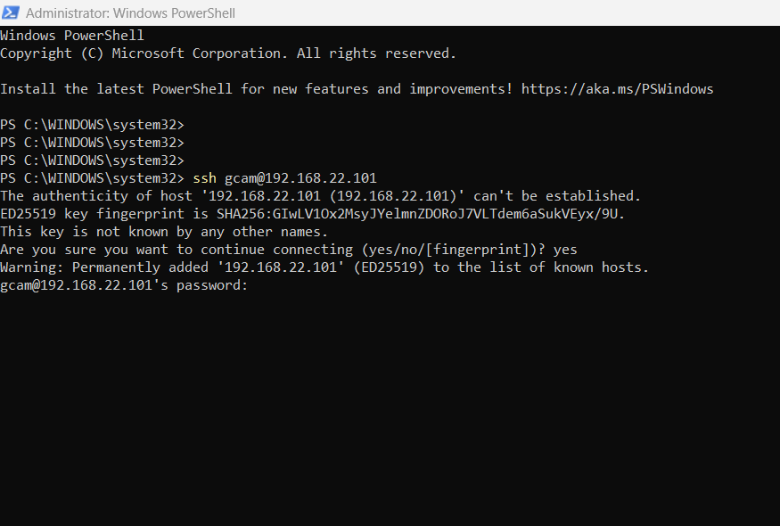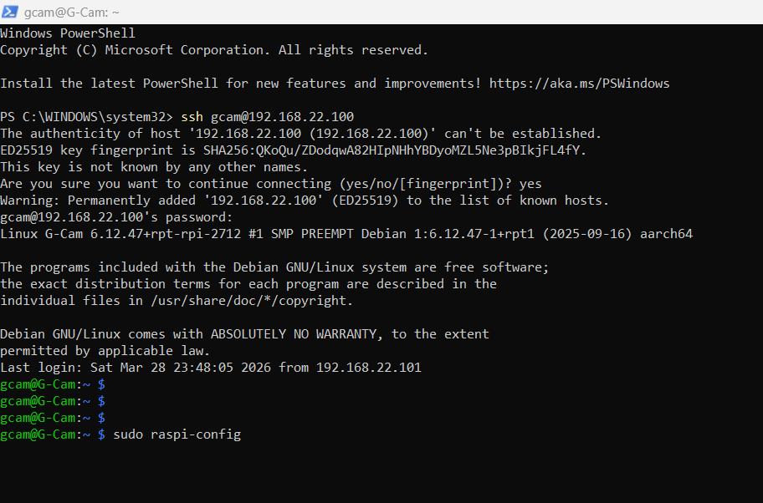
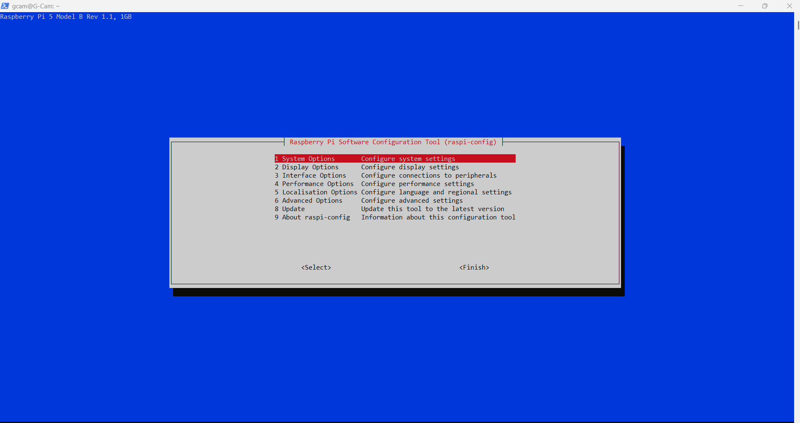
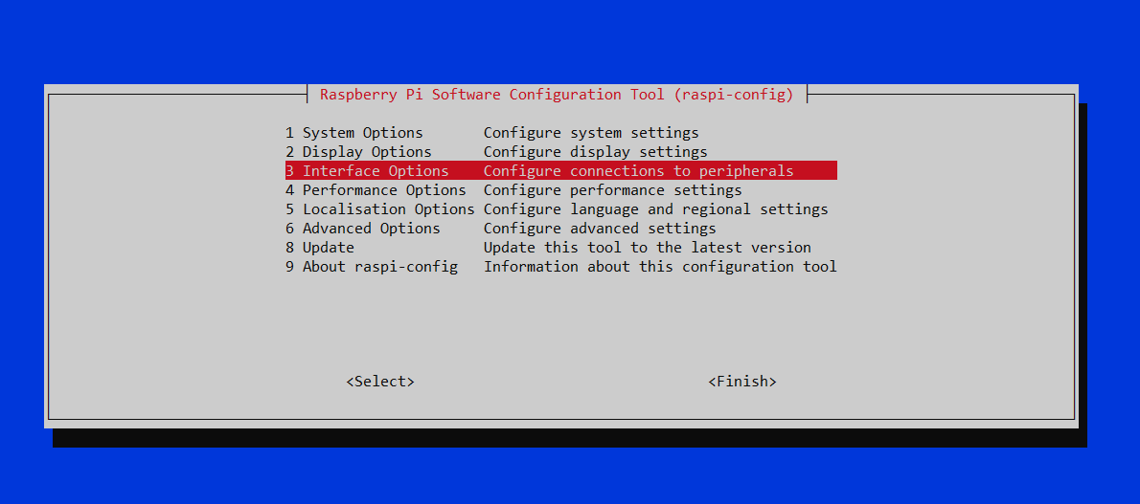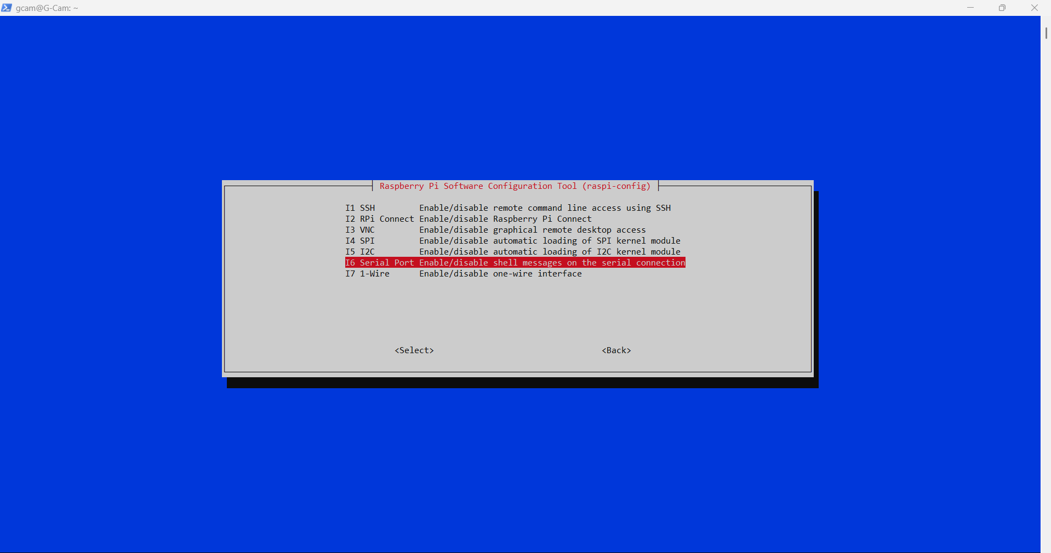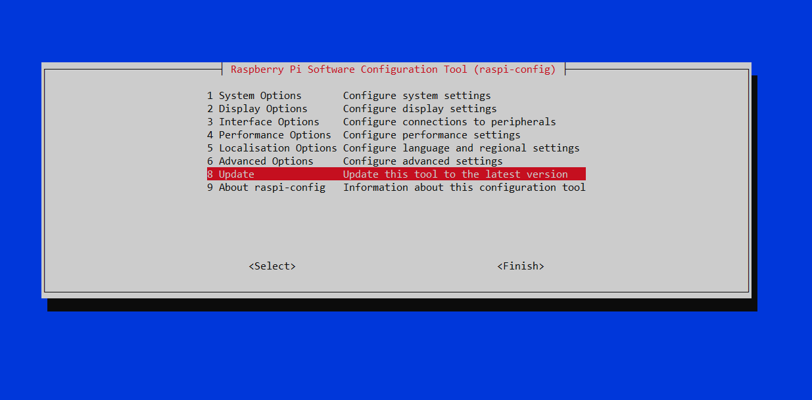

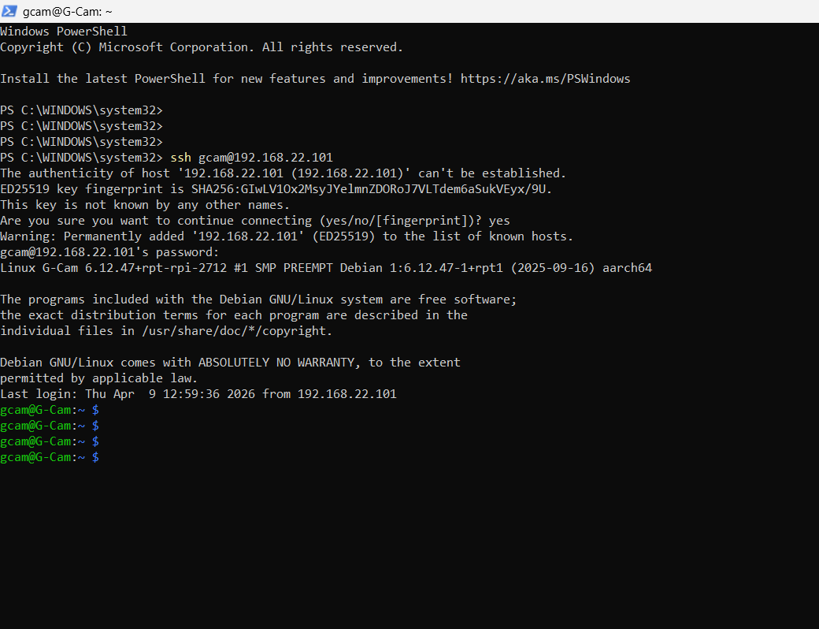
scp "C:\Users\RealTech\Downloads\install.sh" gcam@192.168.22.101:/tmp/install.sh

ssh gcam@192.168.22.101

chmod +x /tmp/install.sh
sudo bash /tmp/install.sh
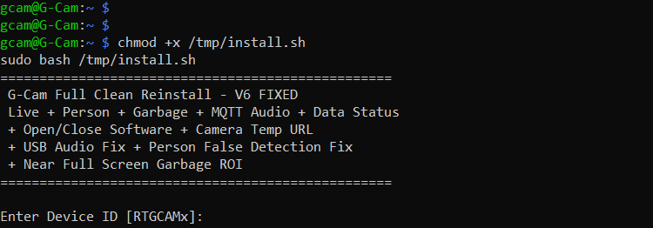
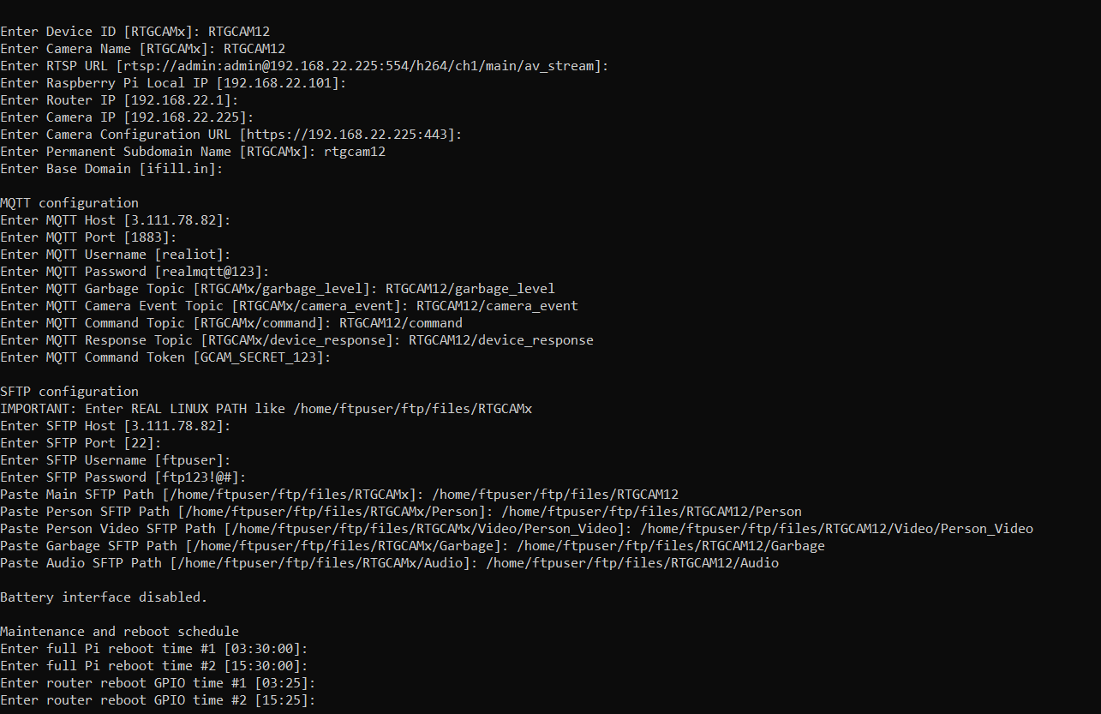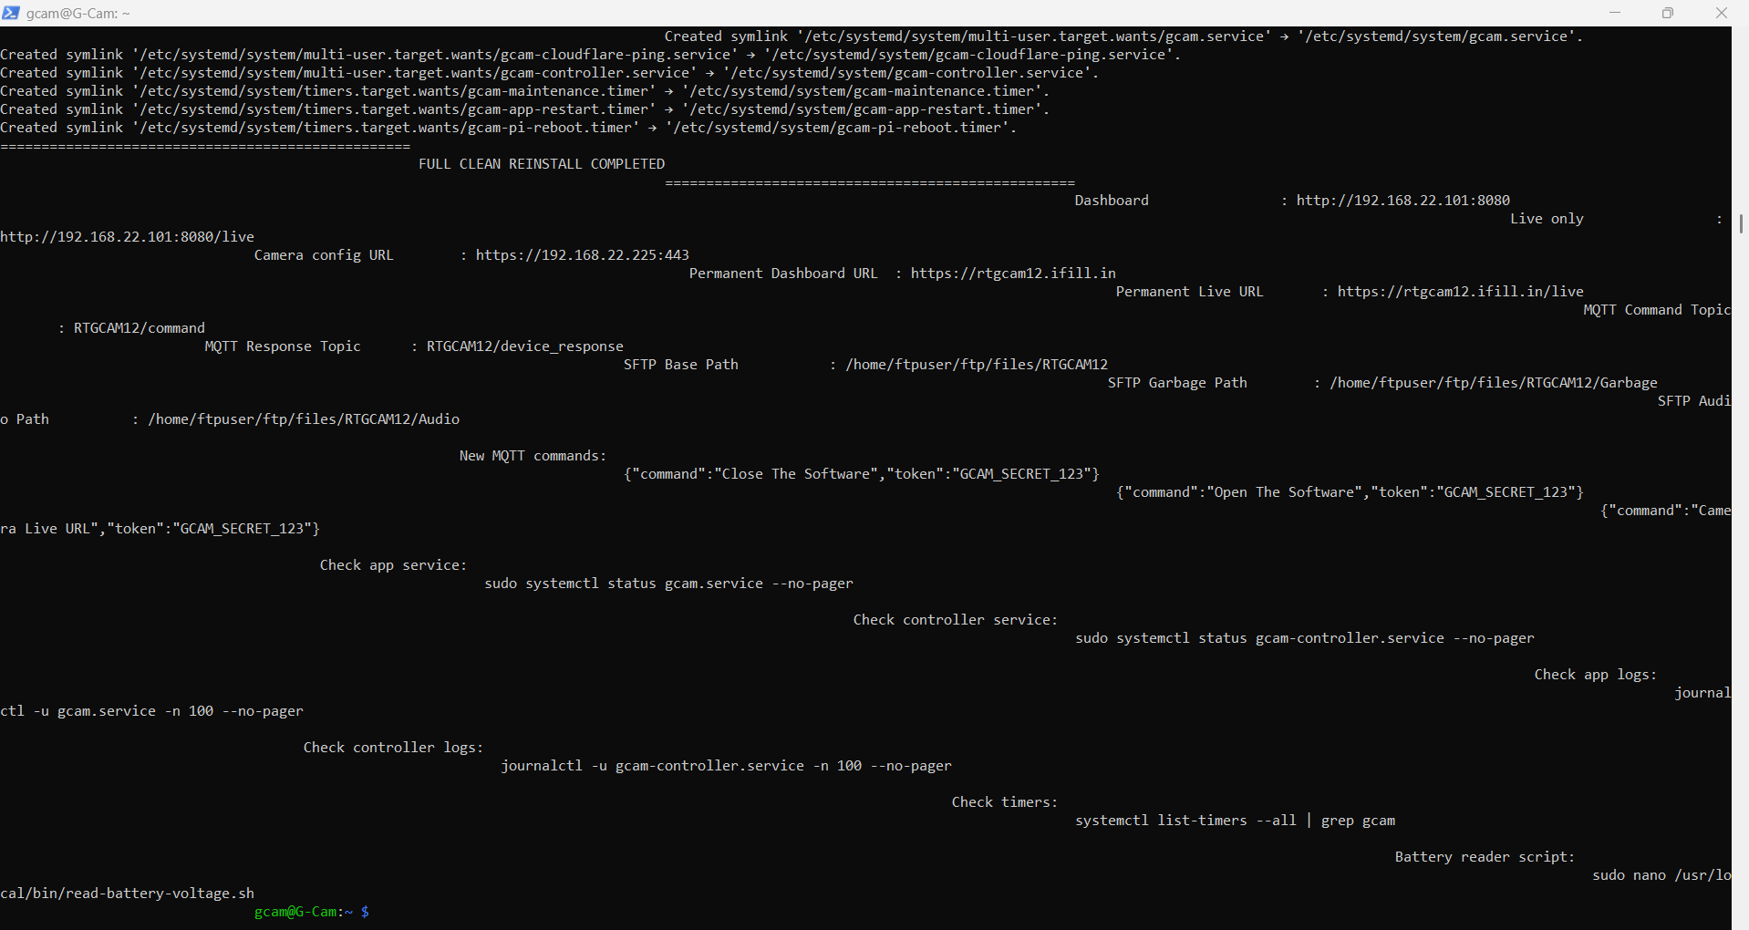
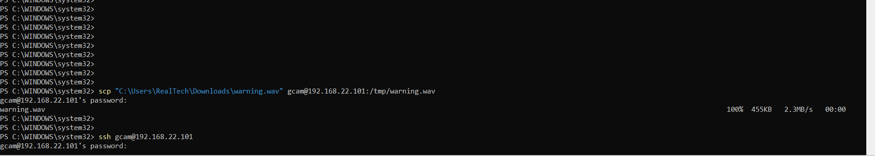
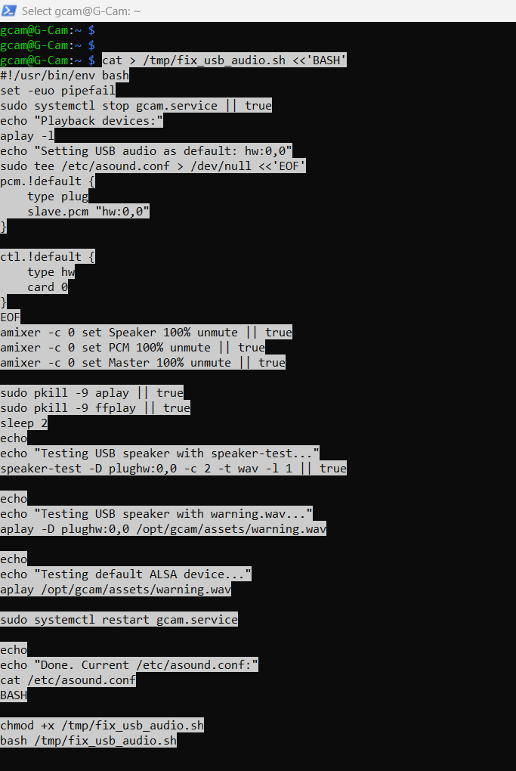
cat > /tmp/fix_usb_audio.sh <<'BASH'
#!/usr/bin/env bash
set -euo pipefail
sudo systemctl stop gcam.service || true
echo "Playback devices:"
aplay -l
echo "Setting USB audio as default: hw:0,0"
sudo tee /etc/asound.conf > /dev/null <<'EOF'
pcm.!default {
type plug
slave.pcm "hw:0,0"
}

ctl.!default {
type hw
card 0
}
EOF
amixer -c 0 set Speaker 100% unmute || true
amixer -c 0 set PCM 100% unmute || true
amixer -c 0 set Master 100% unmute || true

sudo pkill -9 aplay || true
sudo pkill -9 ffplay || true
sleep 2
echo
echo "Testing USB speaker with speaker-test..."
speaker-test -D plughw:0,0 -c 2 -t wav -l 1 || true

echo
echo "Testing USB speaker with warning.wav..."
aplay -D plughw:0,0 /opt/gcam/assets/warning.wav

echo
echo "Testing default ALSA device..."
aplay /opt/gcam/assets/warning.wav

sudo systemctl restart gcam.service

echo
echo "Done. Current /etc/asound.conf:"
cat /etc/asound.conf
BASH

chmod +x /tmp/fix_usb_audio.sh
bash /tmp/fix_usb_audio.sh

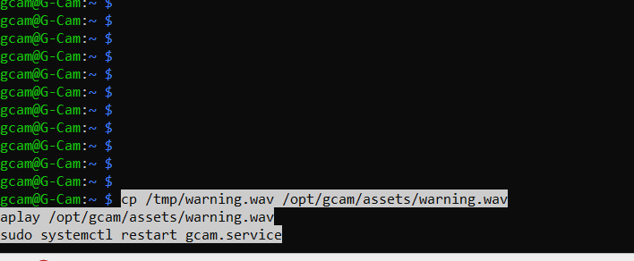
cp /tmp/warning.wav /opt/gcam/assets/warning.wav
aplay /opt/gcam/assets/warning.wav
sudo systemctl restart gcam.service

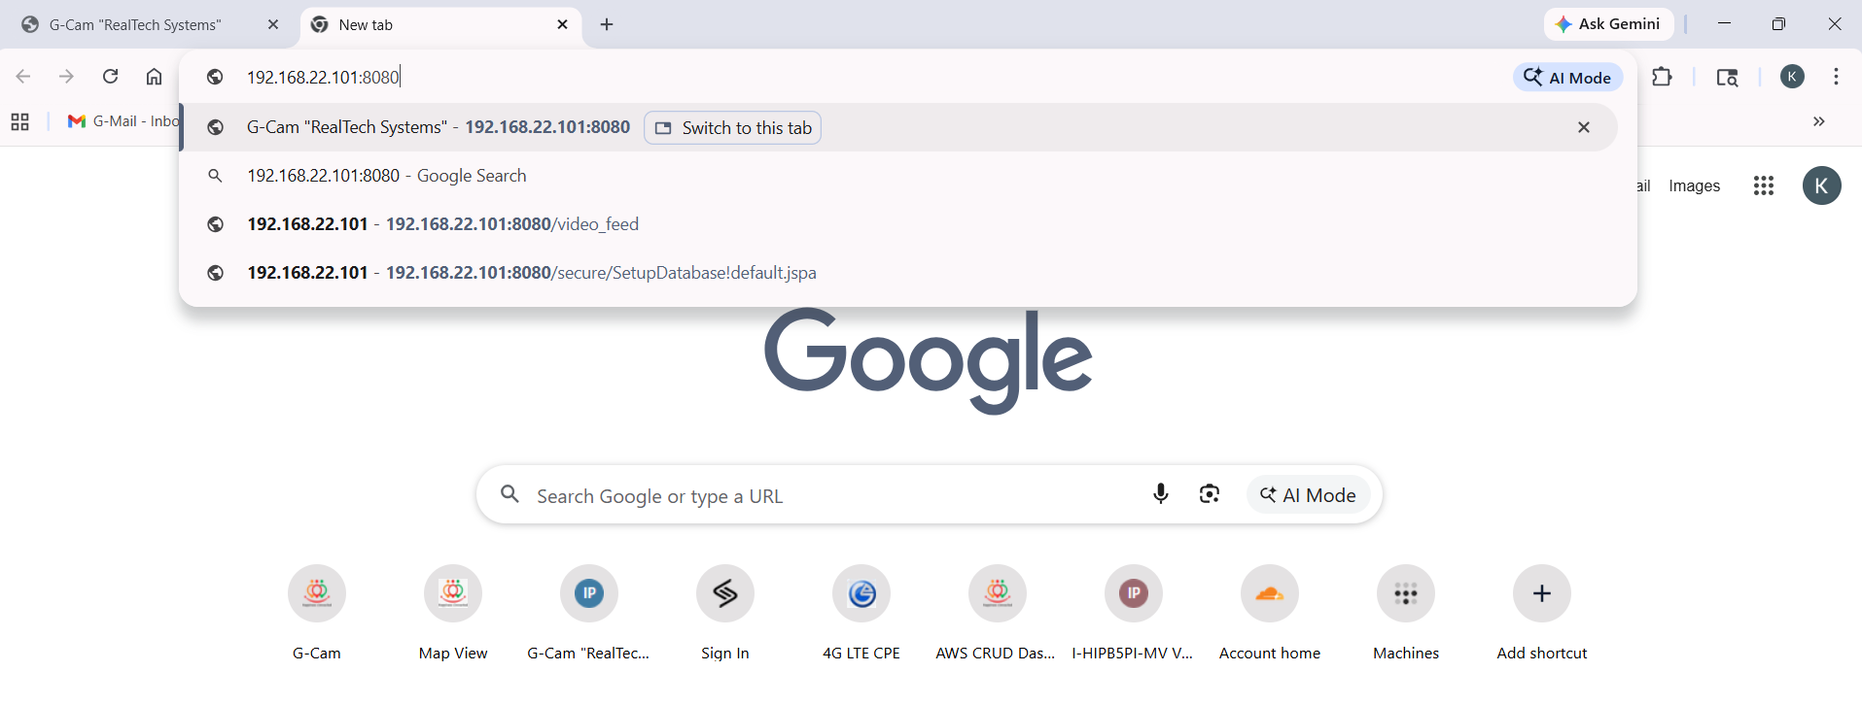
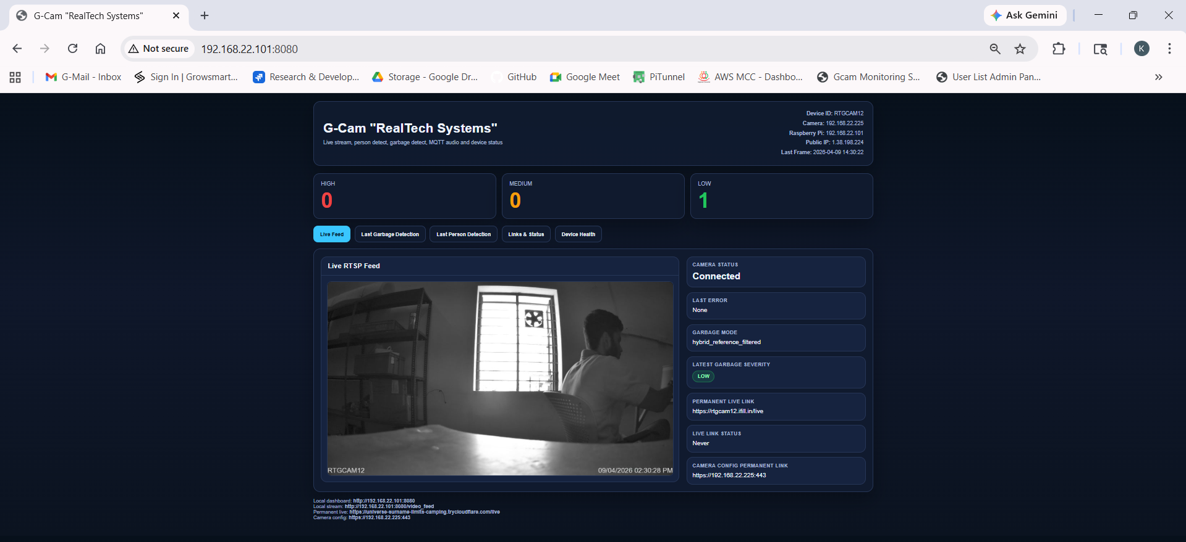

sudo nano /boot/firmware/config.txt

arm_freq=2000
usb_max_current_enable=1

Cntl + O
Enter
Cntl + X

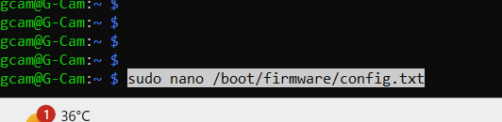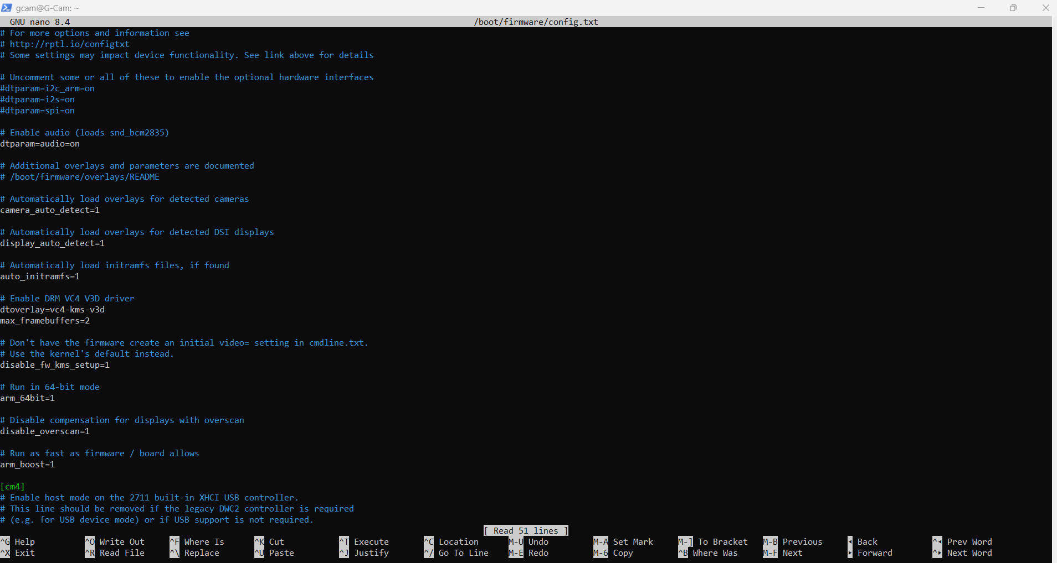
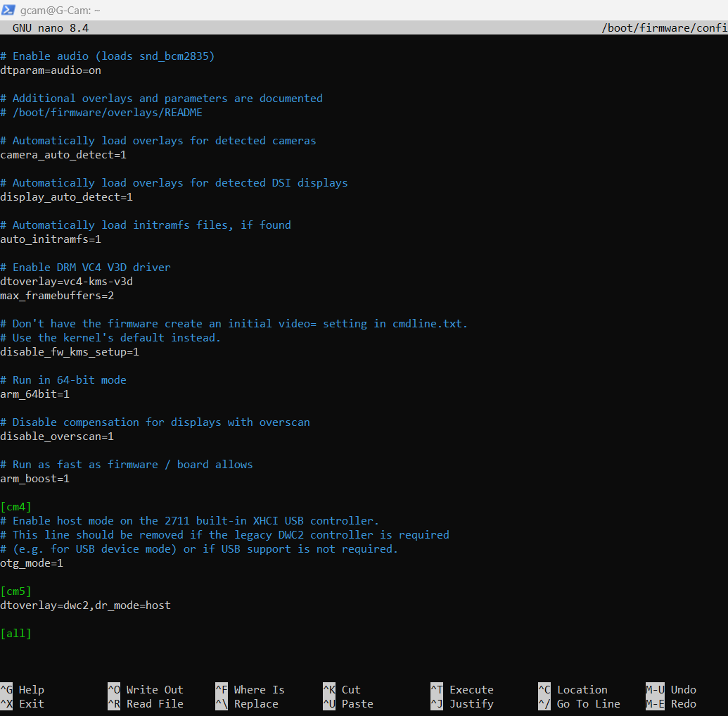
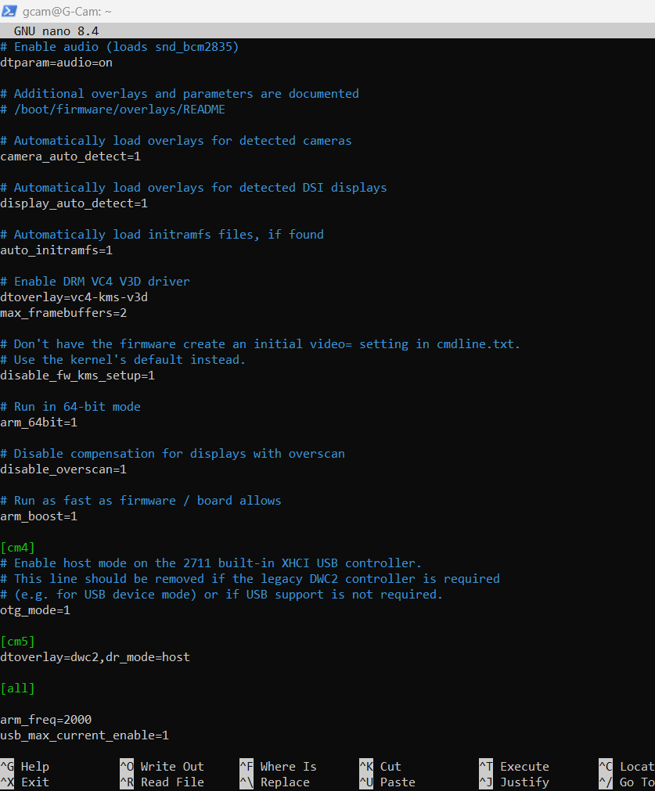

sudo rpi-eeprom-config --edit

PSU_MAX_CURRENT=5000

Cntl + O
Enter
Cntl + X

sudo reboot

